**Azure Cloud Architecture for Batch Processing**

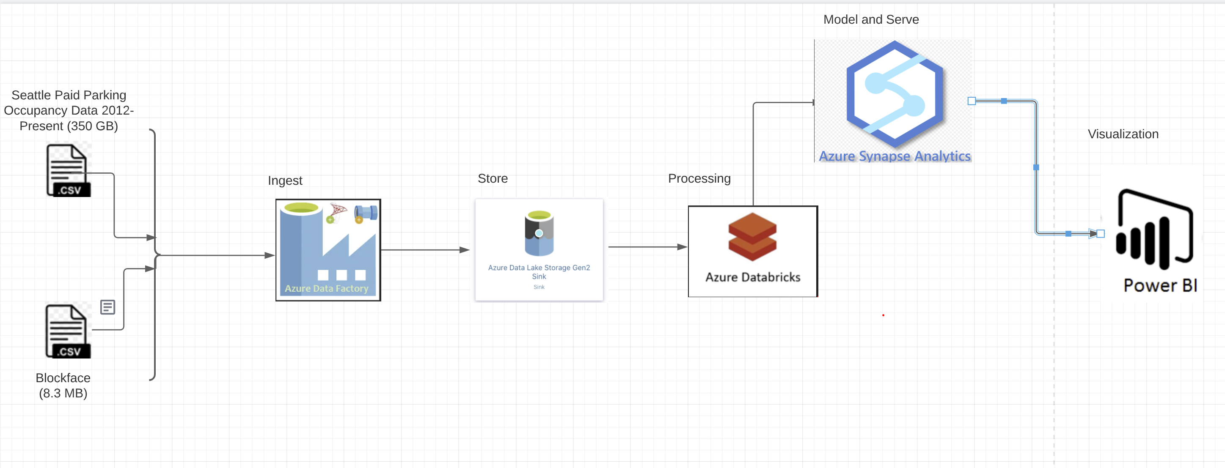

***Data Source:*** *Historical and Delta datasets for Seattle Paid Parking Occupancy from 2012-Present (about 350 GB) and Blockface stored in Azure Fileshare/Containers.*

***Azure Data Factory****: To Ingest the data from Storage Account Fileshare/Container to Azure Data Lake.*

***Azure Databricks:*** *A data analytics platform to process big data using Spark. For a big data pipeline, the data (raw or structure) is ingested into Azure Data Lake through Azure Data Factory in batches and processed using Spark in Azure Databricks.*

***Azure Synapse Analytics:*** *Azure synapse is a limitless service to perform Big data analytics on processed data.*

***Power BI:*** *A Synapse Integrated feature to visualize the data.*

Azure Data Factory to orchestrate entire data pipeline.

**Azure Data Lake**

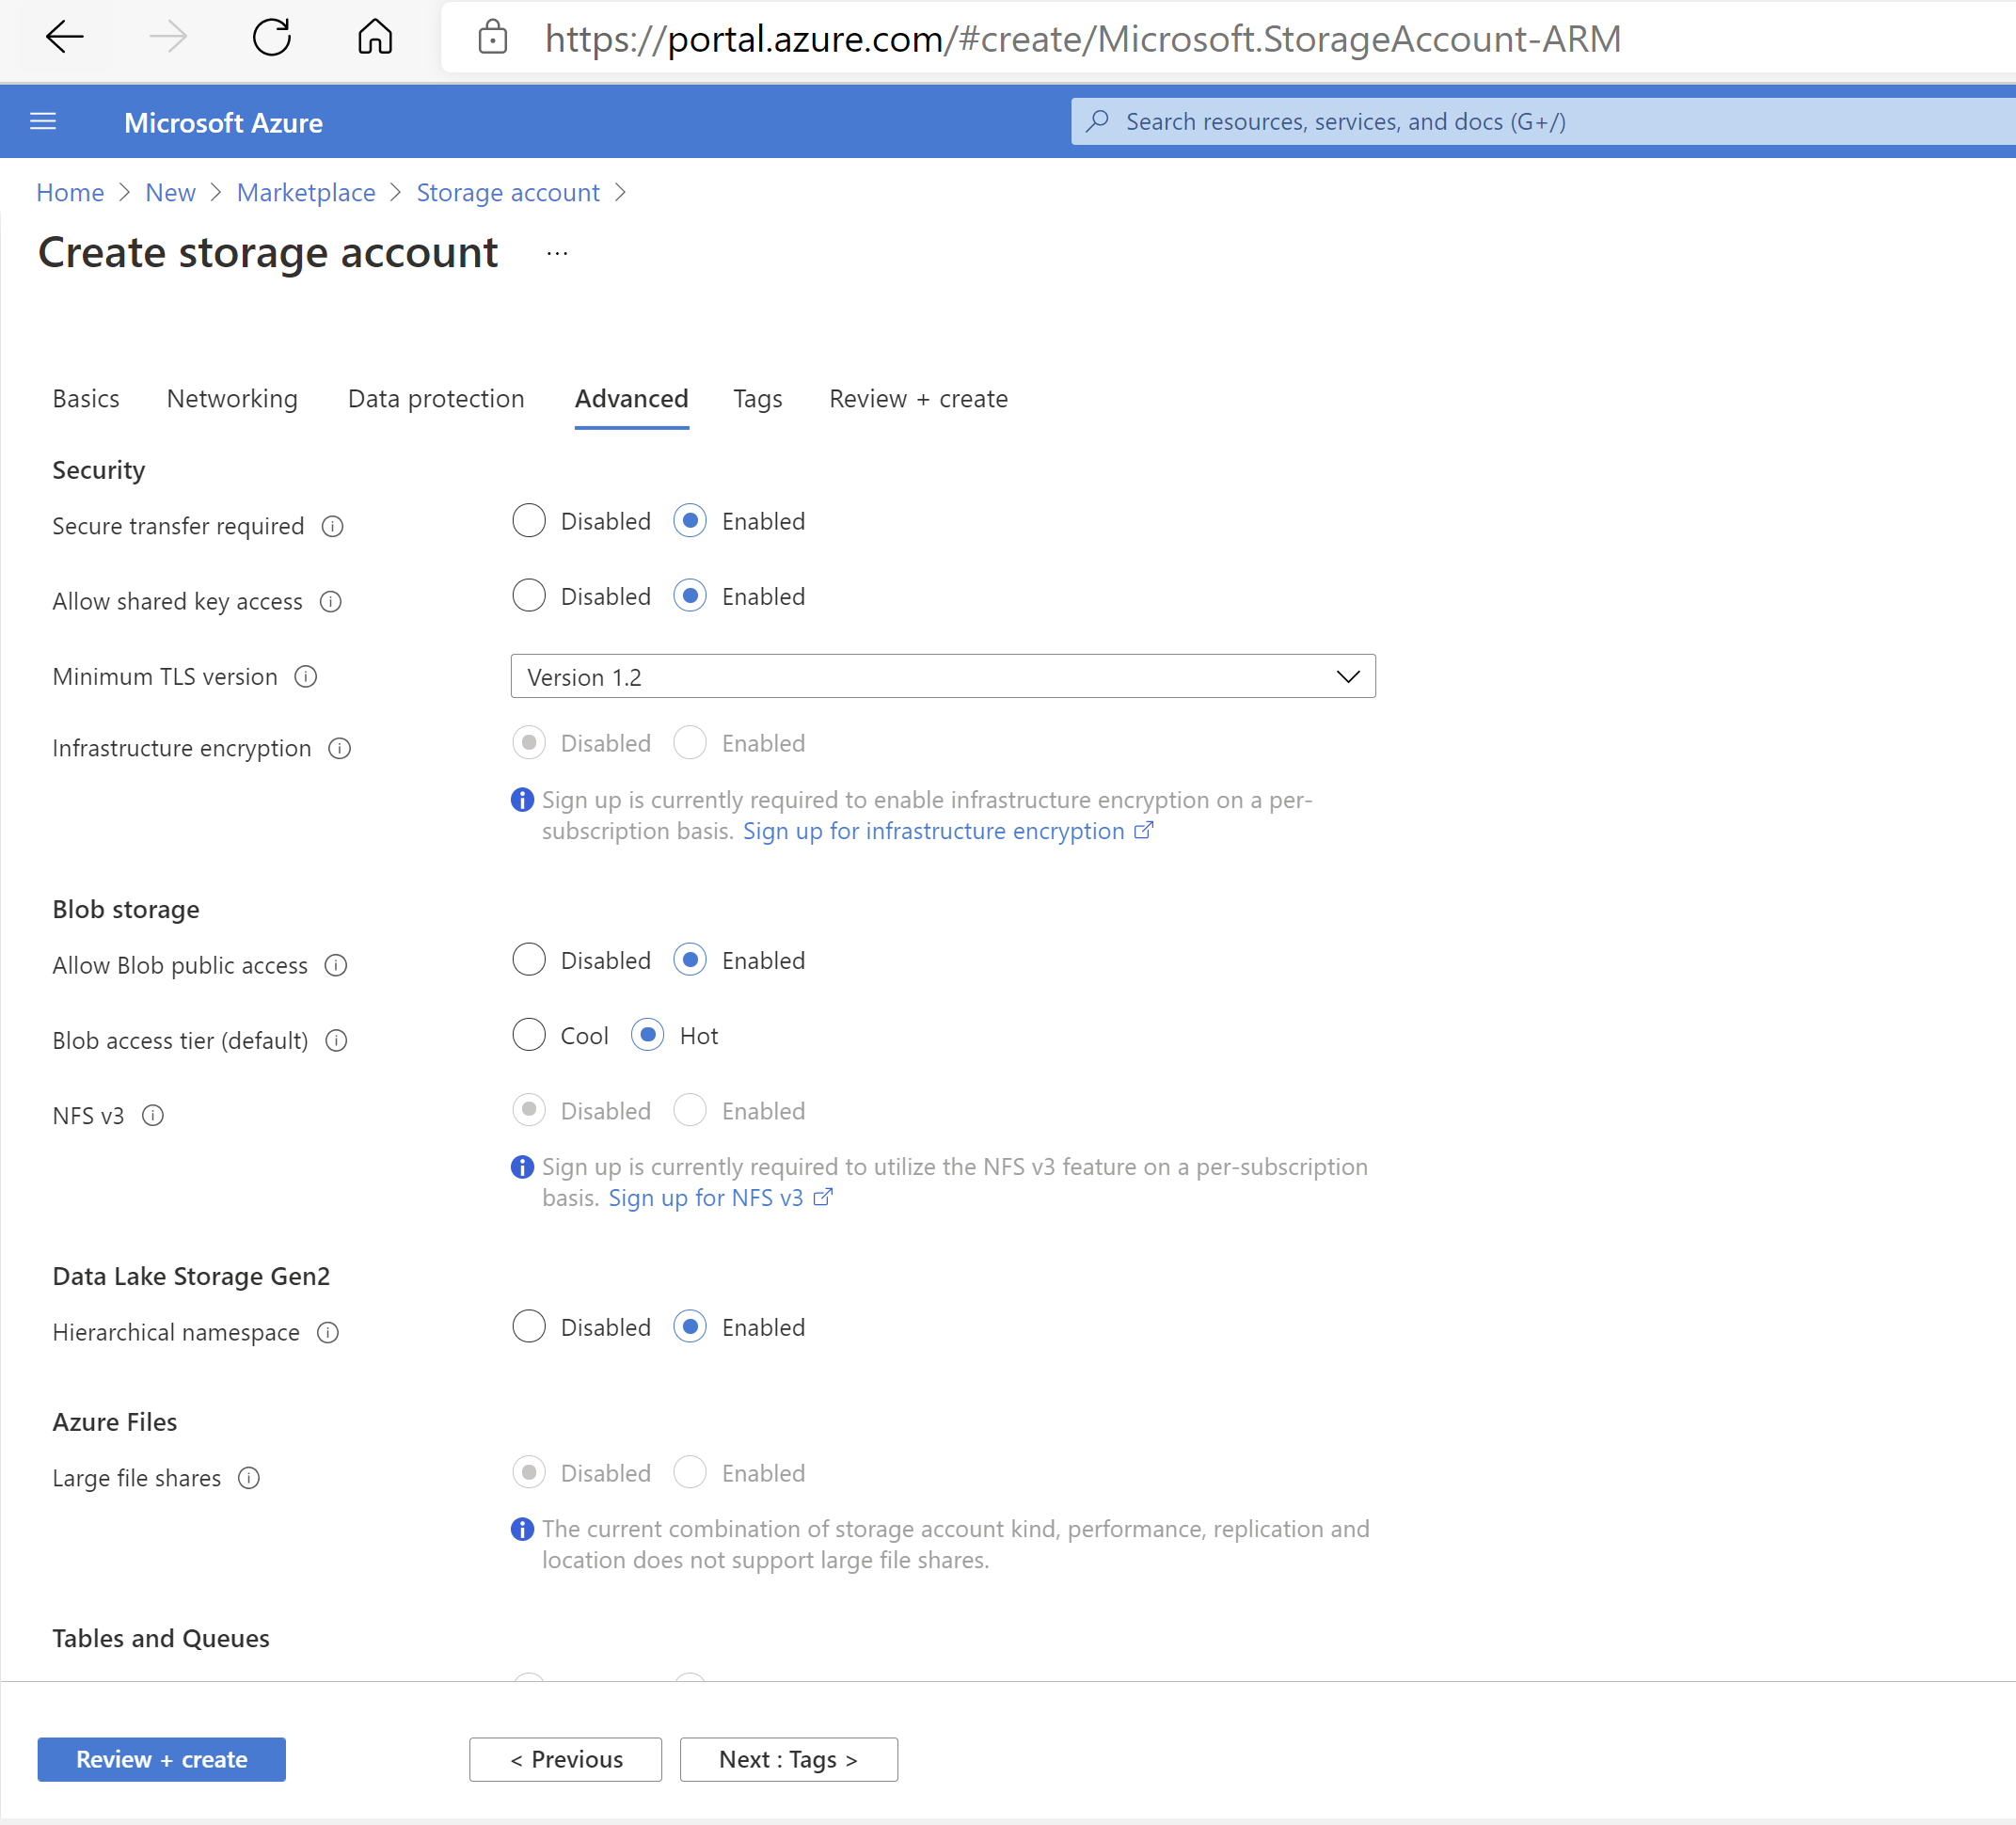

**Azure Data Lake Resource Template**

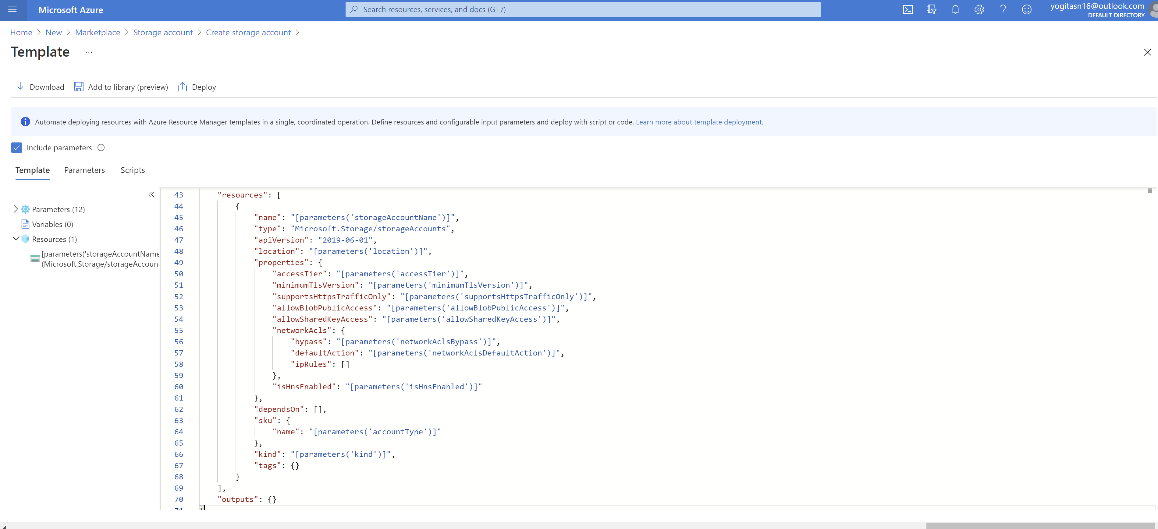

**Azure Data Factory**

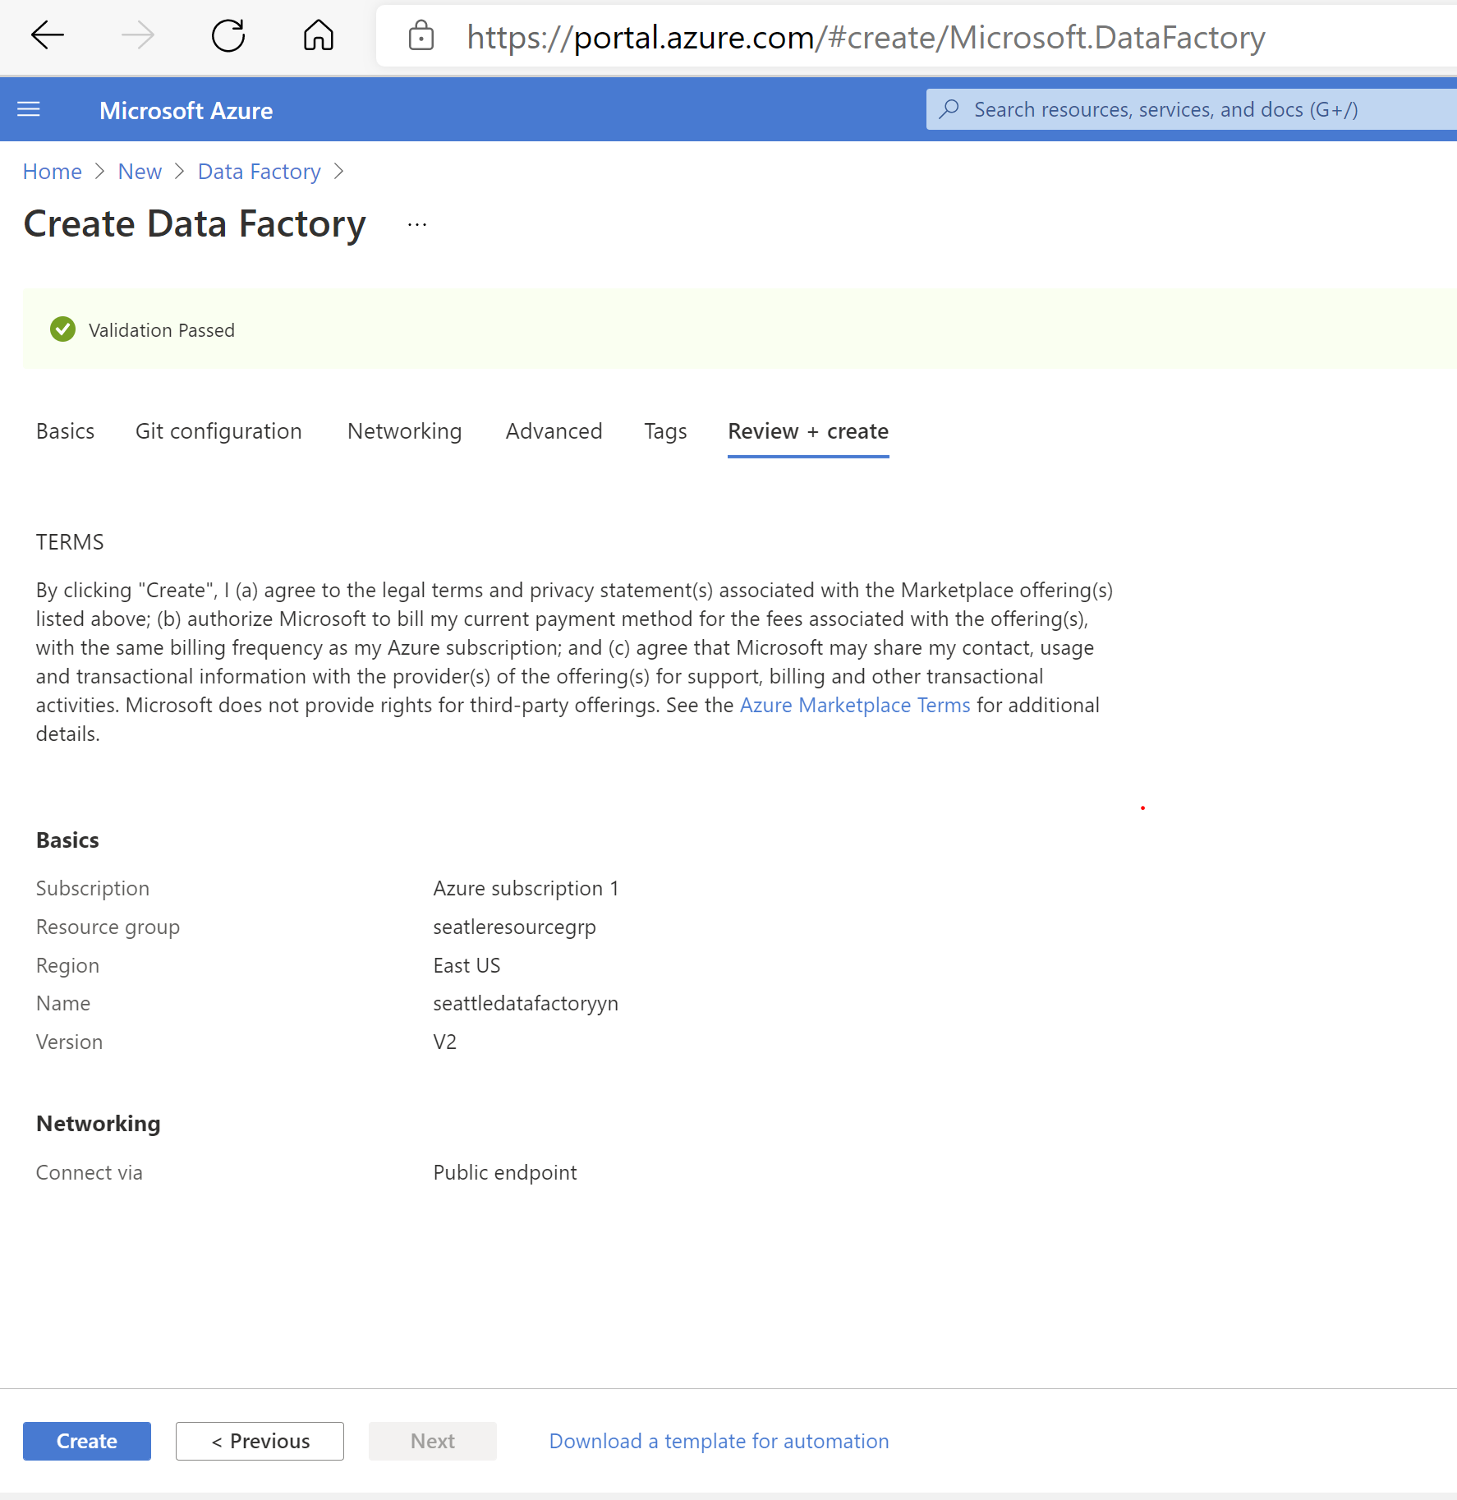

**Data Factory Resource Template**

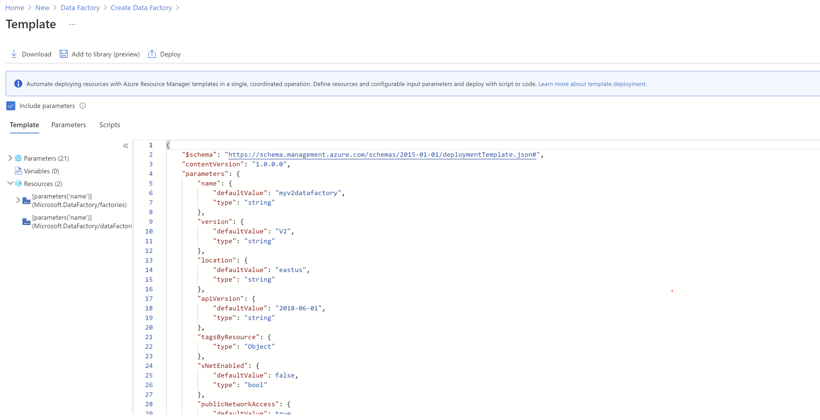

**Azure Databricks**

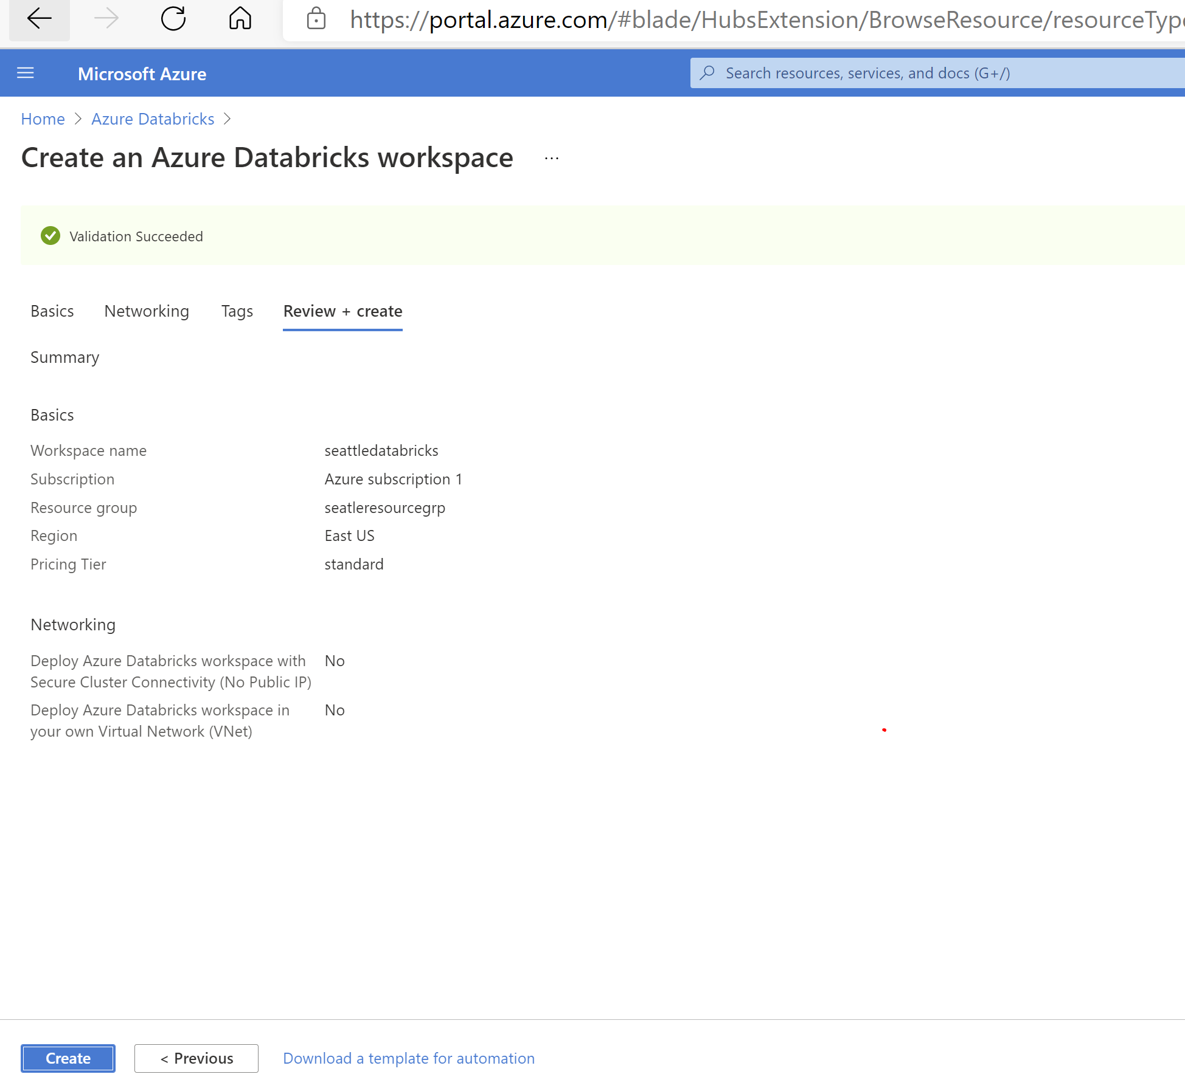

**Azure Databricks Resource Template:**

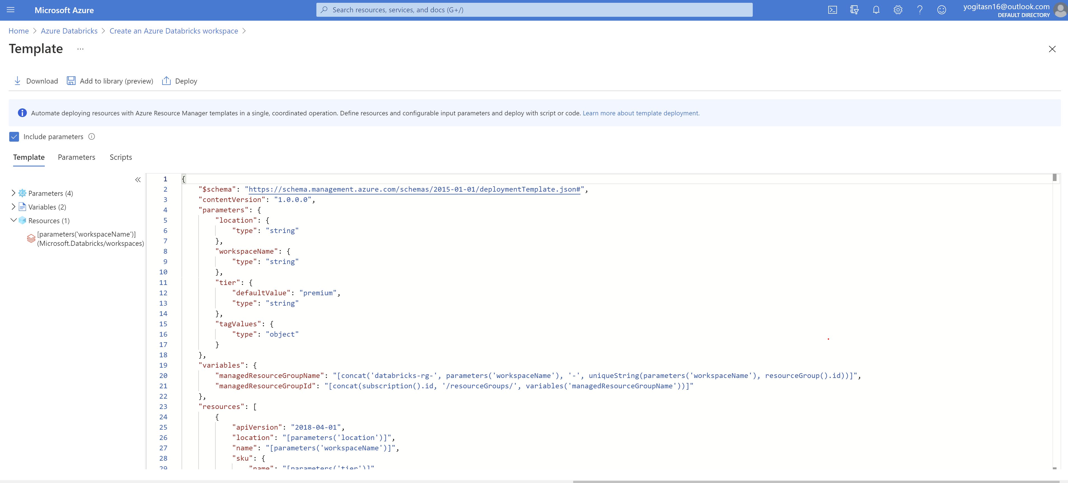

**Azure Synapse Analytics:**

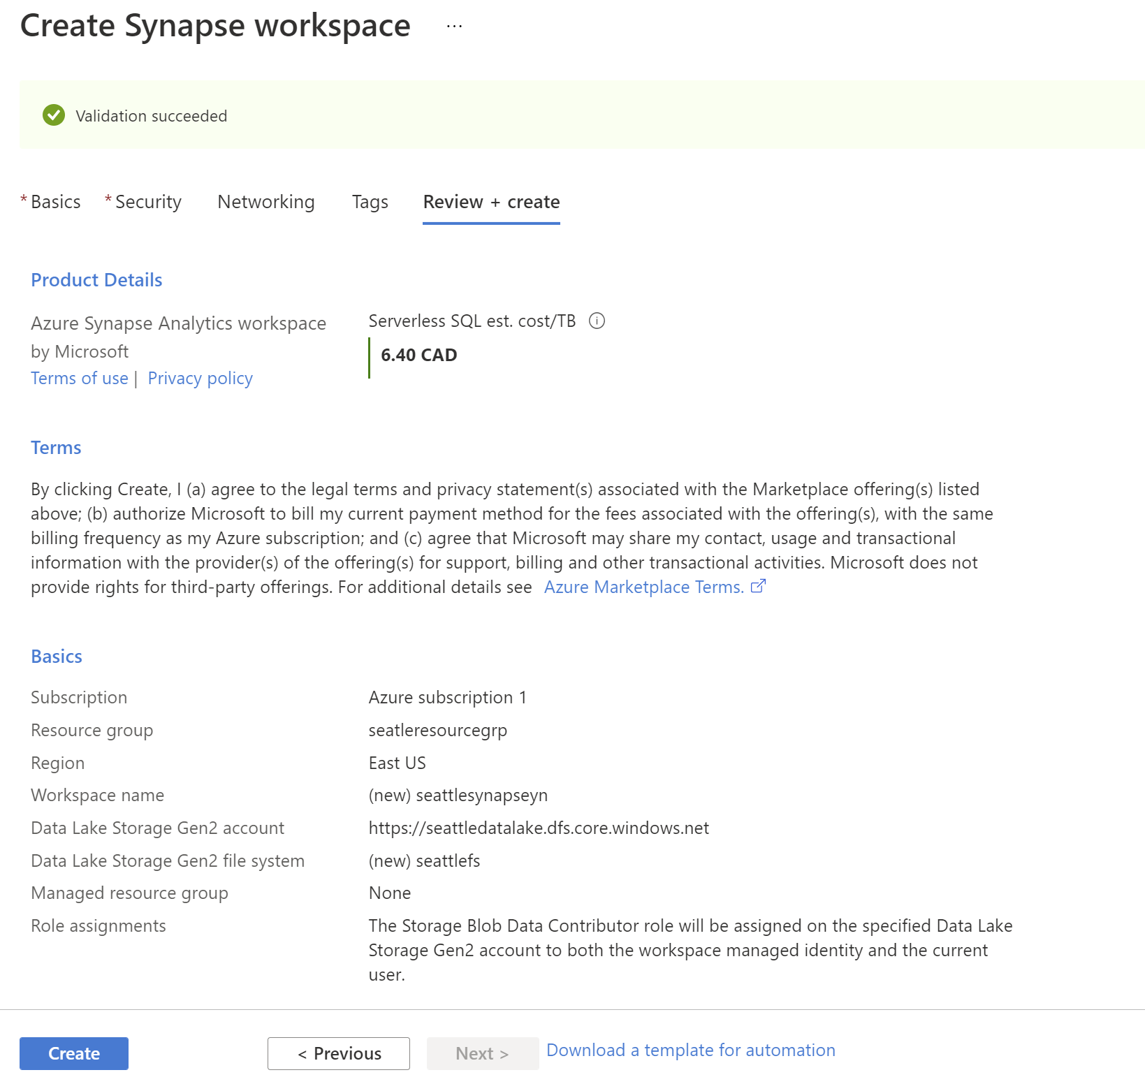

**Azure Synapse Resource Template**

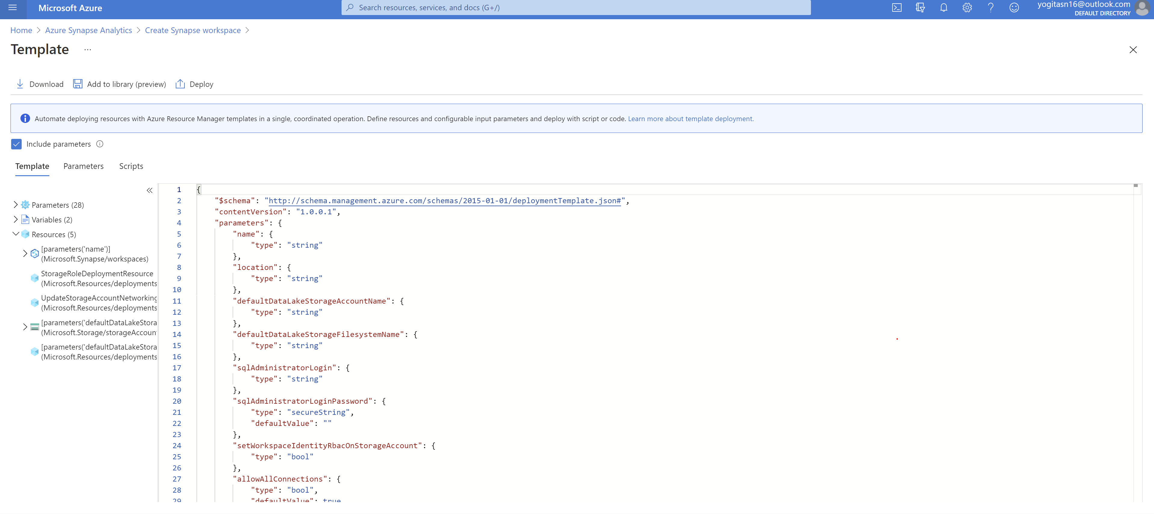

**Cloud Architecture for Real-time processing:**

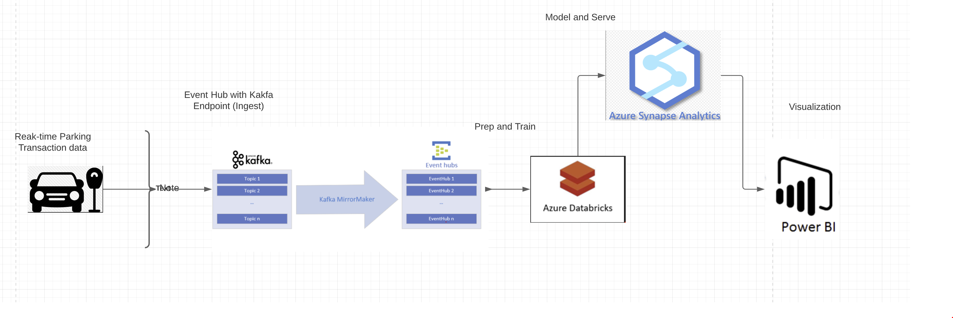

***Data Source:*** *Transaction data available in real-time.*

***Event Hubs with Kafka endpoint:*** *The Event Hubs for Kafka feature provides a****protocol head on top of Azure Event Hubs****that is binary compatible with Kafka versions 1.0 and later for both reading from and writing to Kafka topics.*

***Azure Databricks:*** *A data analytics platform to process big data using Spark. For a big data pipeline, the data (raw or structure) is ingested into Azure through Azure Data Factory streamed near real-time using Apache Kafka*

***Azure Synapse Analytics:*** *Azure Synapse Analytics is an analytics service that brings together enterprise data warehousing and Big Data analytics.*

***Power BI:***  *A Synapase Integrated feature to visualize the data.*